**DAILY ONLINE ACTIVITIES SUMMARY**

|  |  |  |  |  |  |  |  |
| --- | --- | --- | --- | --- | --- | --- | --- |
| **Date:** | **08-06-2020** | | | | **Name:** | **B.A.SOHANKUMAR** | |
| **Sem & Sec** | **4TH SEM A** | | | | **USN:** | **4ÀL18CS013** | |
| **Online Test Summary** | | | | | | | |
| **Subject** | | **COMPLEX ANALYSIS , PROBABILITY AND STATISTICAL METHOD** | | | | | |
| **Max. Marks** | | **30** | | **Score** | | **24** | |
| **Certification Course Summary** | | | | | | | |
| **Course** | **DATA VISUALIZATION USING PYTHON** | | | | | | |
| **Certificate Provider** | | | **GREAT LEARNING ACADEMY** | **Duration** | | | **2 HOURS** |
| **Coding Challenges** | | | | | | | |
| **Problem Statement:1:Write a c++ program to swap a two numbers using the bridge concept.**  **Problem Statement:2:Write a java program to check whether the given matrix is a magic square or not.**  **Problem Statement:3:C program to generate all the set partitions of the n numbers beginning from 1 to so on.** | | | | | | | |
| **Status:EXECUTED** | | | | | | | |
| **Uploaded the report in Github** | | | | **YES** | | | |
| **If yes Repository name** | | | | **LOCKDOWN CODING** | | | |
| **Uploaded the report in slack** | | | | **YES** | | | |

**ONLINE TEST DETAILS:**

Today test was on 2nd module of COMPLEX ANALYSIS , PROBABILITY AND STATISTICAL METHOD(18MAT41).The duration of the test is 40 minutes from 09.30am to 10.00 am.Questions were of multiple choice.Score I received is 24/30.

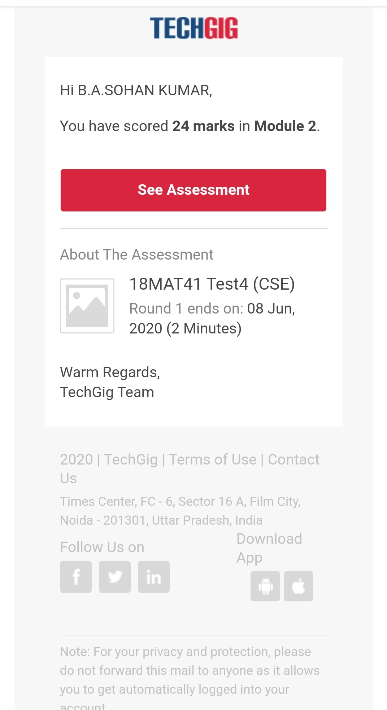

**CERTIFICATION COURSE DETAILS:**

Course:Data visualization using python.

Today I have opted new course and the duration of the course is 2 hours and there were 7 topics that are Introduction to Visualization,Matplotlib, Seaborn and Plotly,Visualization Techniques and Comparing Different plots on Automobile Dataset,Numpy,Pandas (Kaggle Games Dataset),Data Visualization using Seaborn (Kaggle Games Dataset).

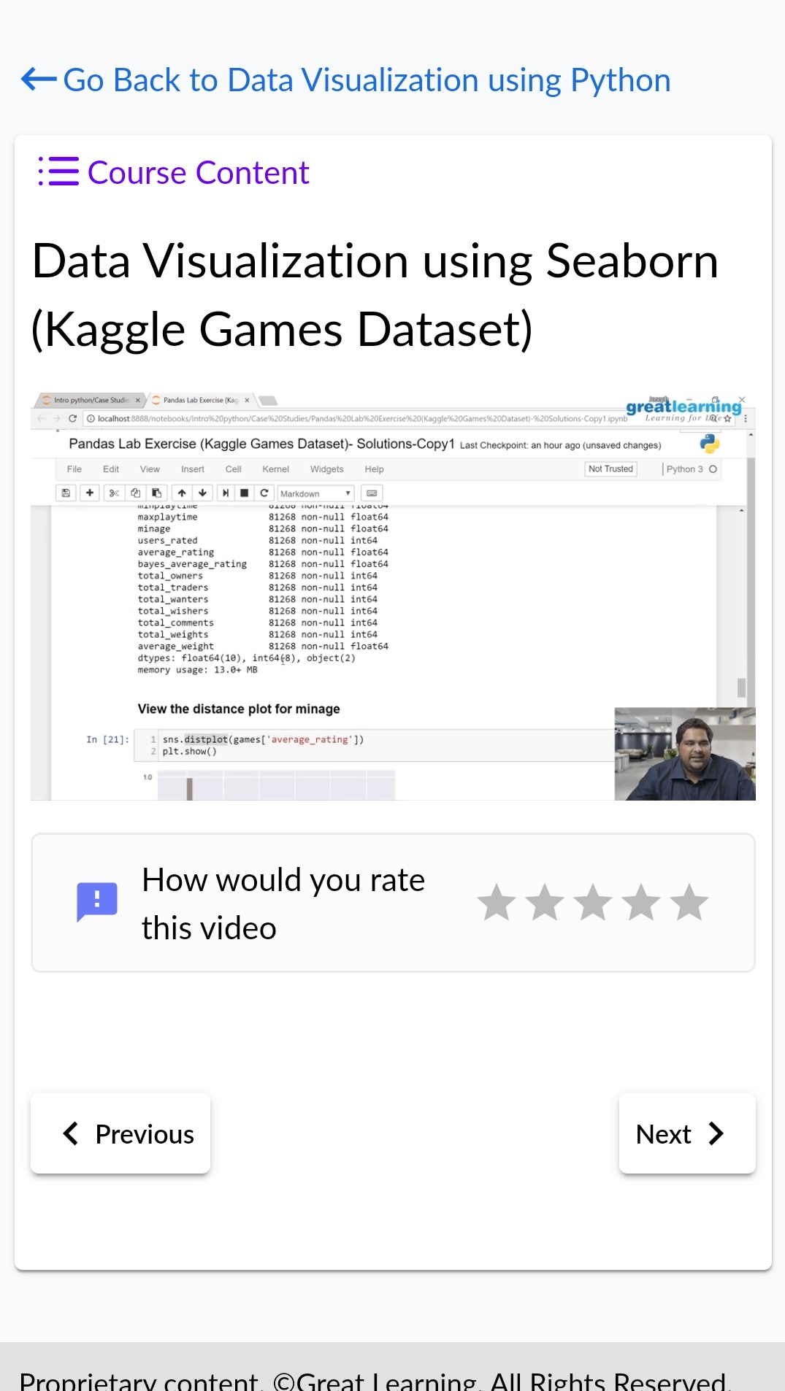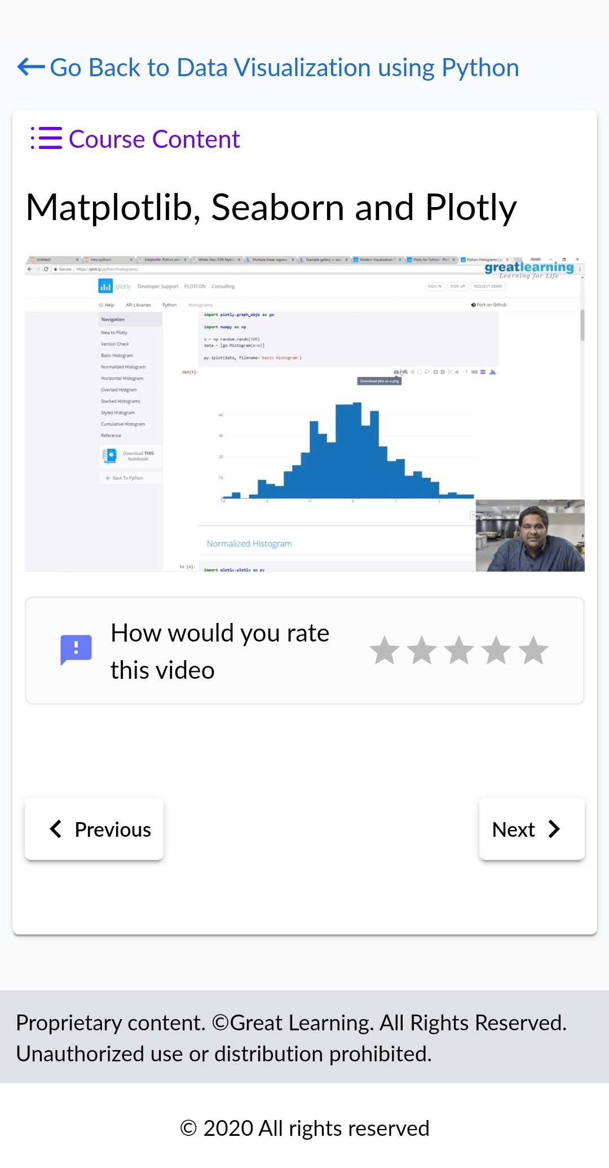

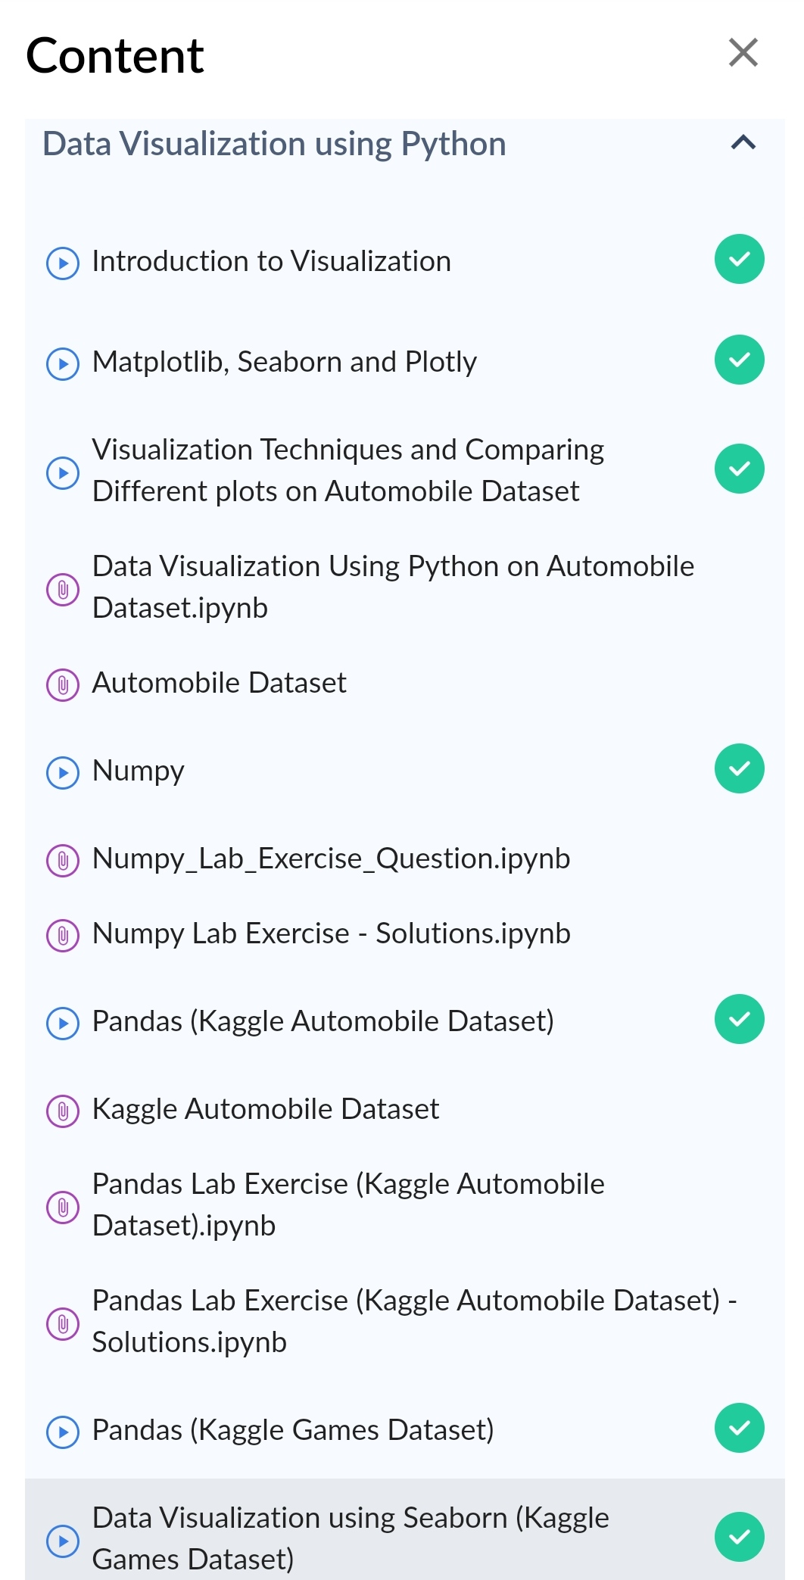

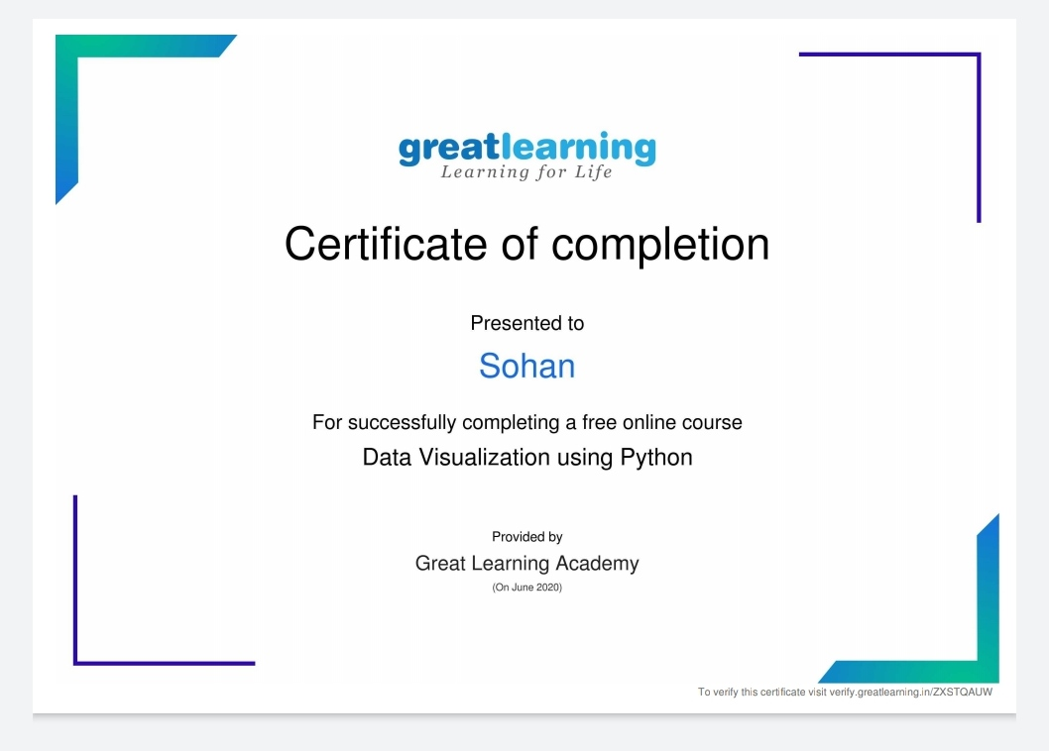

Above certificate is awarded for the completion of this course.

**CODING CHALLENGES DETAILS**:

1.Write a c++ program to swap a two numbers using friend as a bridge concept.

Example:Input a=10 b=20

Output a=20 b=10

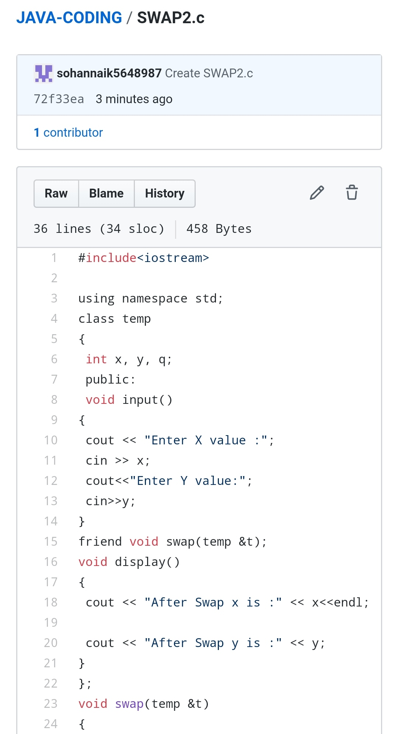

2.Write a java program to Check whether the given matrix is magic square or not.Given a matrix, check whether it’s Magic Square or not. A Magic Square is a n x n matrix of distinct element from 1 to n2 where sum of any row, column or diagonal is always equal to same number.

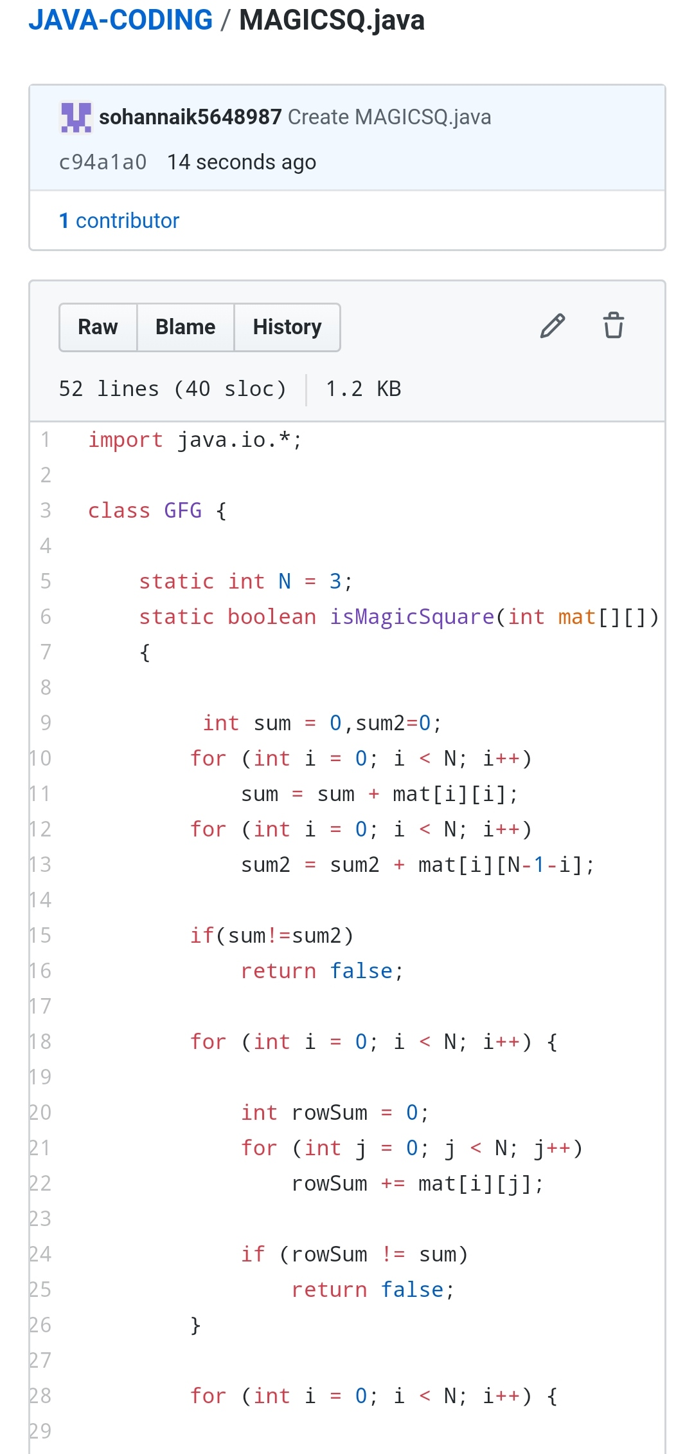

3.C program to generate all the set partitions of n numbers beginning from 1 and so on.This algorithm partitions an integer into numbers which sum up to form the original number. It generates partitions of a set of numbers for a given range.

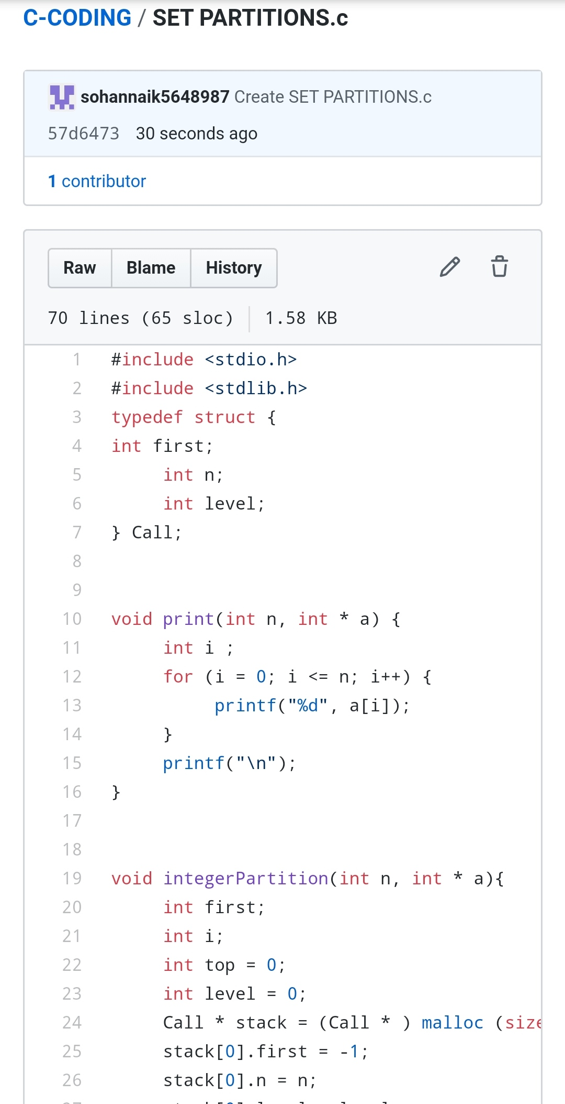

REPOSITORY LINK: https://github.com/sohannaik5648987/C-CODING

https://github.com/sohannaik5648987/JAVA-CODING